Now we need to add scores to make it more interesting and we need to add some UI to tell the user about tap to start and then we can create the menu.
Now in our sprite folder we can see tap to start image now drag and drop it on the heirarchy as marked below
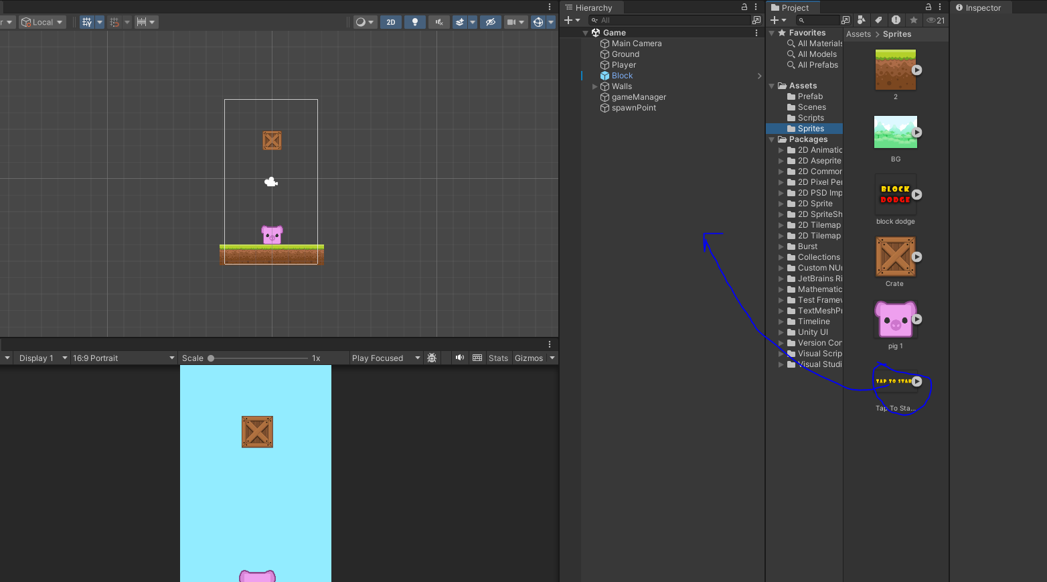
Note:-
If you select the image and then in its inspector sprite mode the single should be selected and if other option is chosen like Multiple then you will not be able to place to drag and drop it on the top of heirarchy
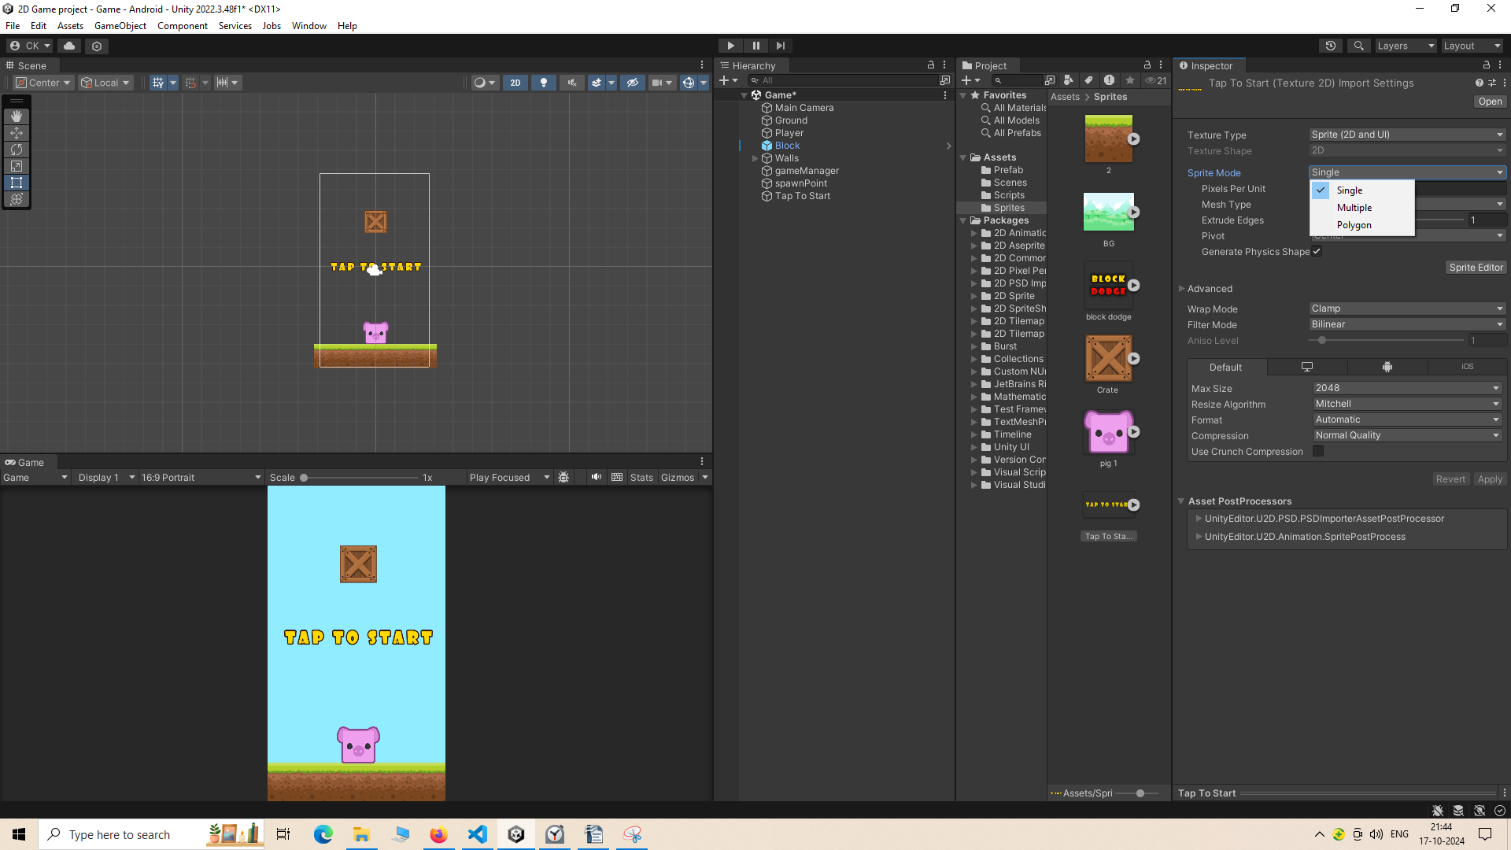
if you have changed it and then you drop it then it will prompt you to save the changes you have commited.
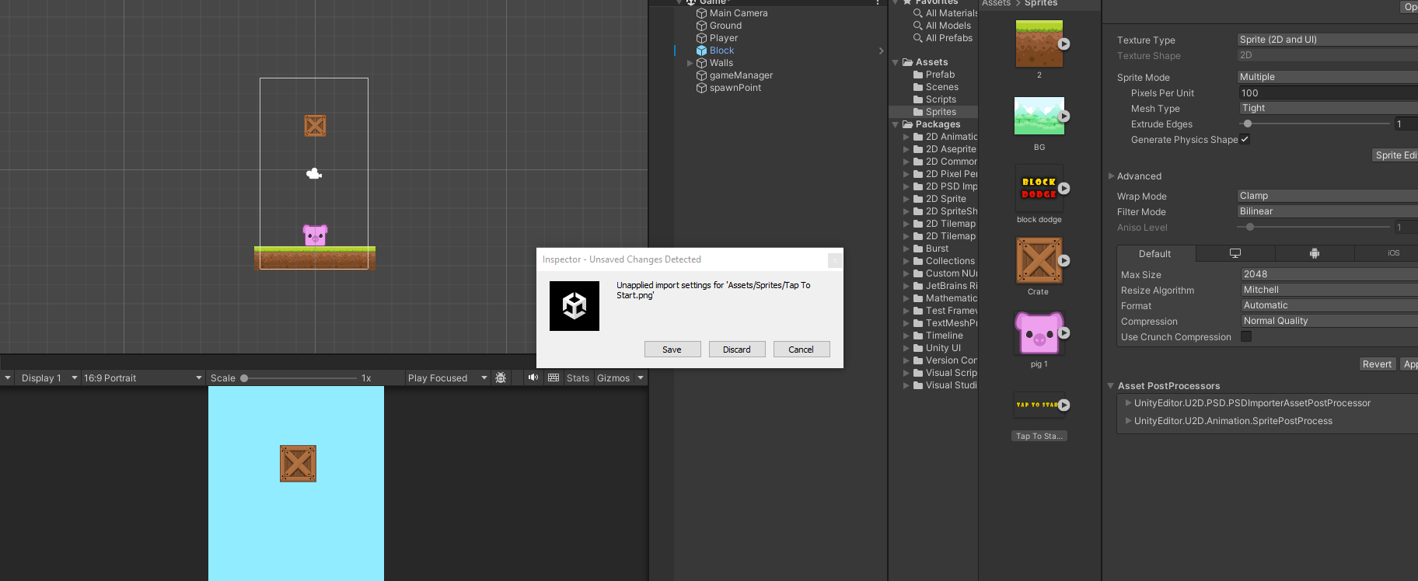
So this tap to start button will be here in the beginning and later it on it will go away
Now we are going to create UI by again clicking on the + button and then a submenu will be opened go to UI and again a submenu will be open beside it and then choose Text-TextMeshPro
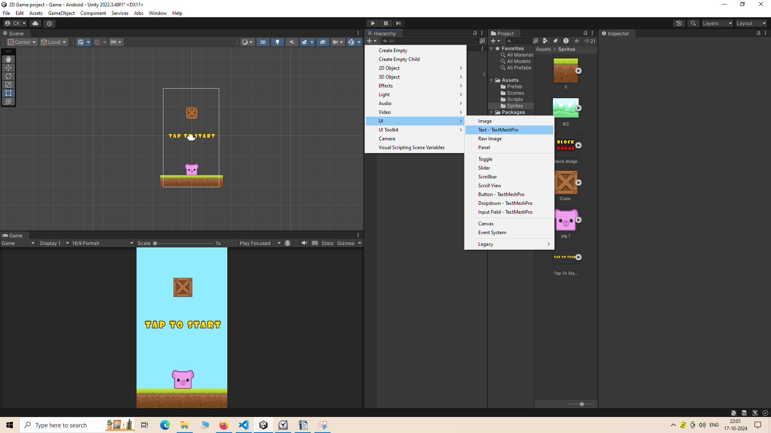
now a sub window will be opened like this as marked below
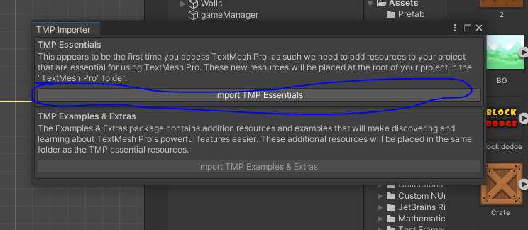
Now click on marked above now text Mesh Pro will appear(imported) in heirarchy panel
like this Now close above small window
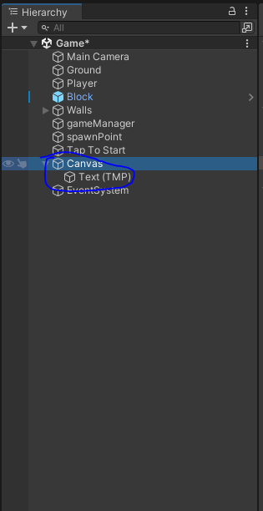
Now there is Canvas parent IOA of TextMeshPro IOA.
We will rename this text into scoreText
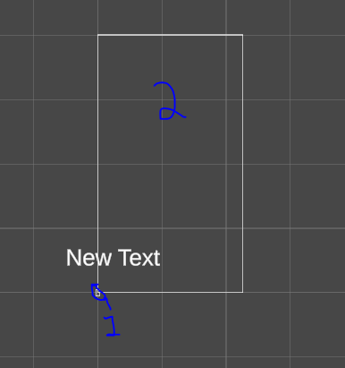
After zooming out The marked 1 area is actually is the main scene we are currently working on.
The rectangle 2 you see above is in the same ratio as your main screen the TMP shown here as New Text whatever its orientation will be in this canvas will be same in the main scene.
I think this canvas is actually mirror of the main camera scene.
In our screen
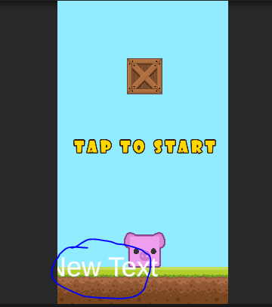
The textMeshpro is not present in the center(or we can say not even present in the screen) so we will reset it then it will come in the center of the canvas or we can say in the center of the scene.
So first we need to do select the canvas in heirarchy
and then go to inspector panel and then go to canvas scaler subpanel
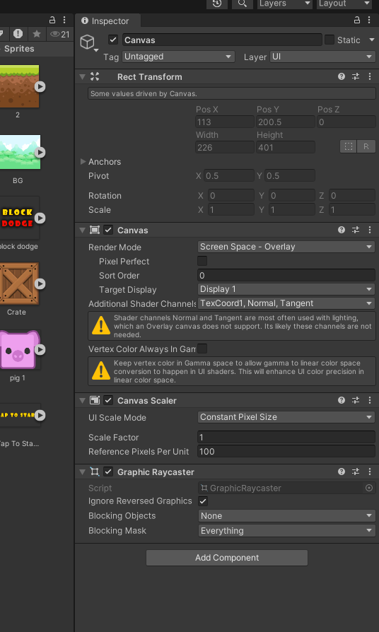
and then in UI scale mode field when you click on it a submenu will be opened
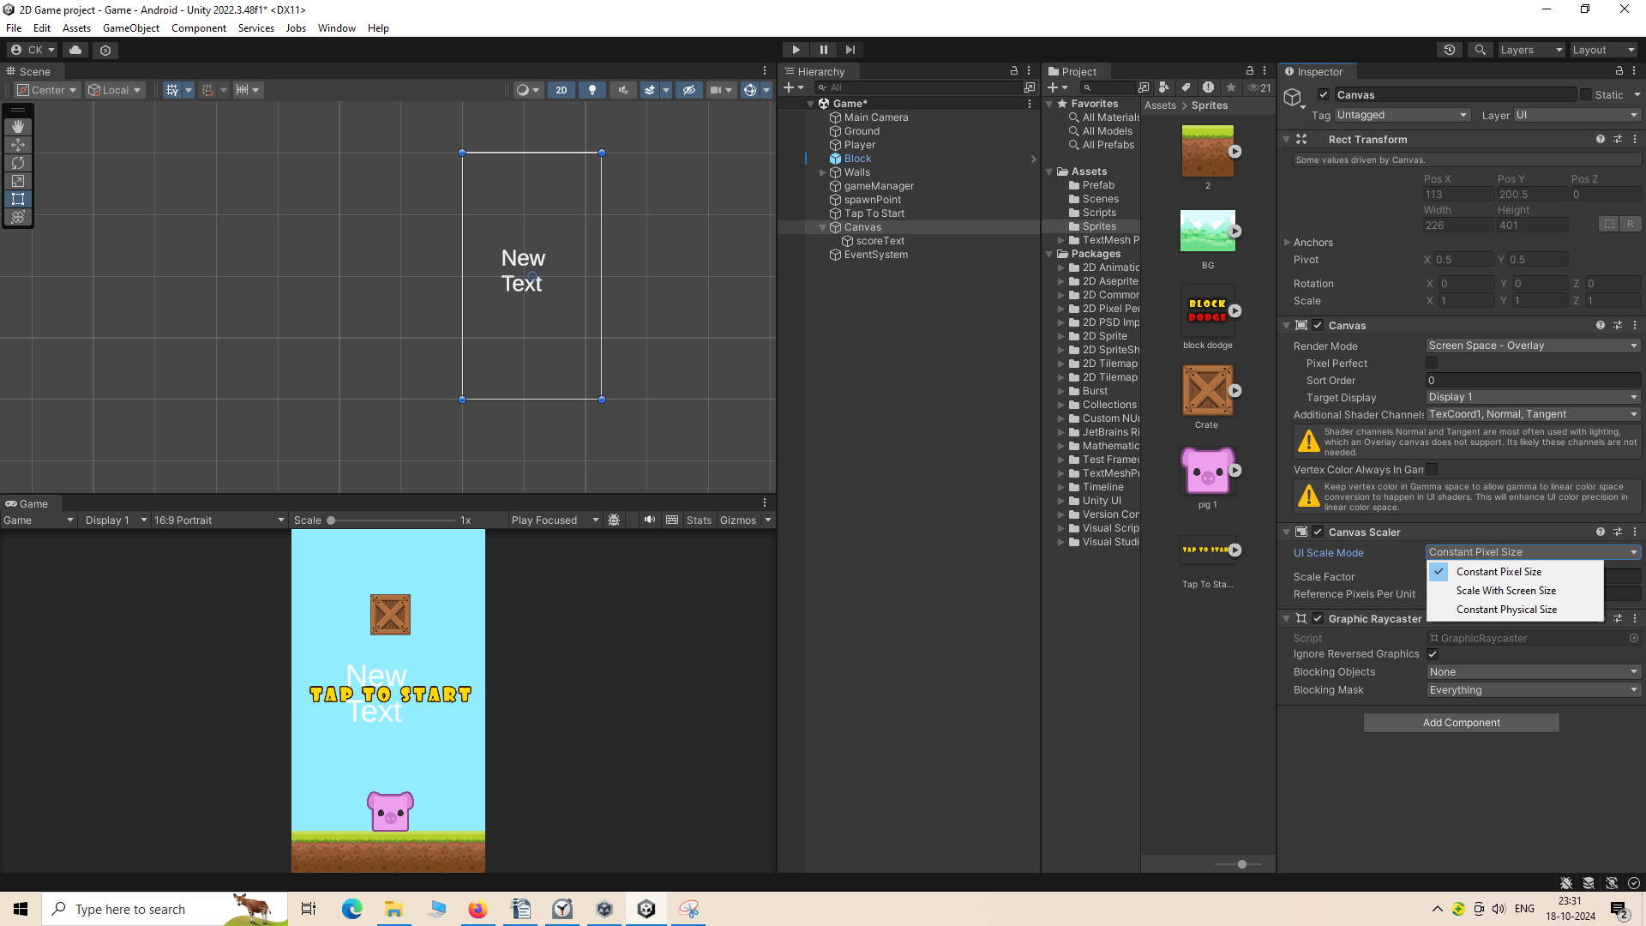
The submenu contains options like
Constant Pixel Size
Scale with screen size
Constant Physical size
We choose Scale with screen size
after this the Canvas Scaler
subpanel will look like this
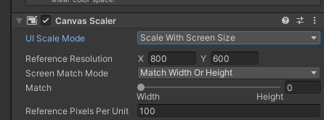
Now make the Reference Resolution 1080 and 1920
Now the text is shown according to this resolution or ascpect ratio and shown in the screen
Note:-
I think the less pixel has the work to show image so it creates a big and worn out image
and when the pixel increases it becomes small and looks good because now many pixel can show it perfectly

When you set a reference resolution, TextMeshPro uses it as a guide to scale the text and its layout appropriately. This is particularly important for responsive design, as it allows you to maintain a uniform look and feel for text on devices with varying resolutions.
(I will research about it later)
and now in match make it 0.5 or move the slider to mid so that it will be scaled accirding to the width and height
And now we will increase the size of our TextMesh Pro by rec tool and then move it at the top , you can move it by dragging it from anchor point which is usually in the center and now it will look like this
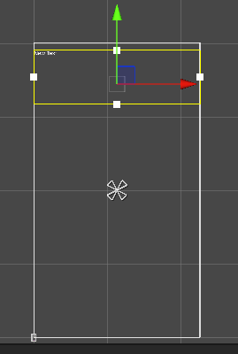

Now we will change the content of text mesh pro
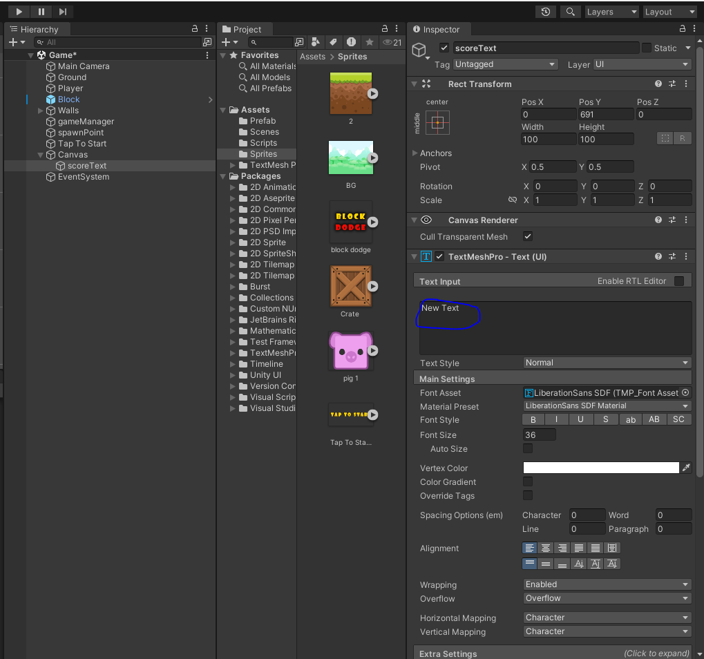
By selecting the TextMEshpro IOA in the Heirarchy and then go to inspector and then to text input subpanel remove it and type 0 to represent our score
Now we will also change the font size to make it big enough we keep it 300
and in alignment we make it to center horizontally and vertically by doing as marked below

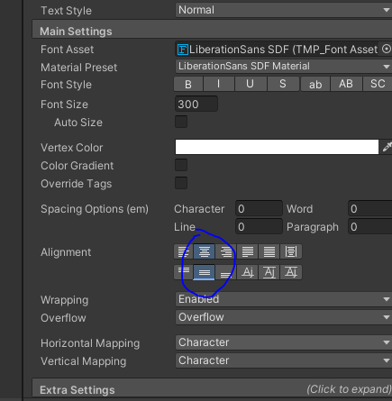
now our screen will look like this
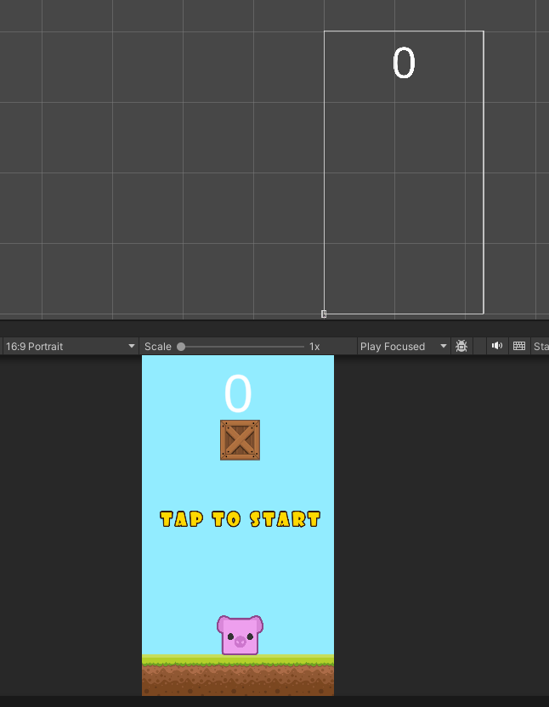
and now when the increases we will increment it
To change the color of the text
you can choose the color from vertex color by clicking on the bar then a small temperory window will be opened as shown below
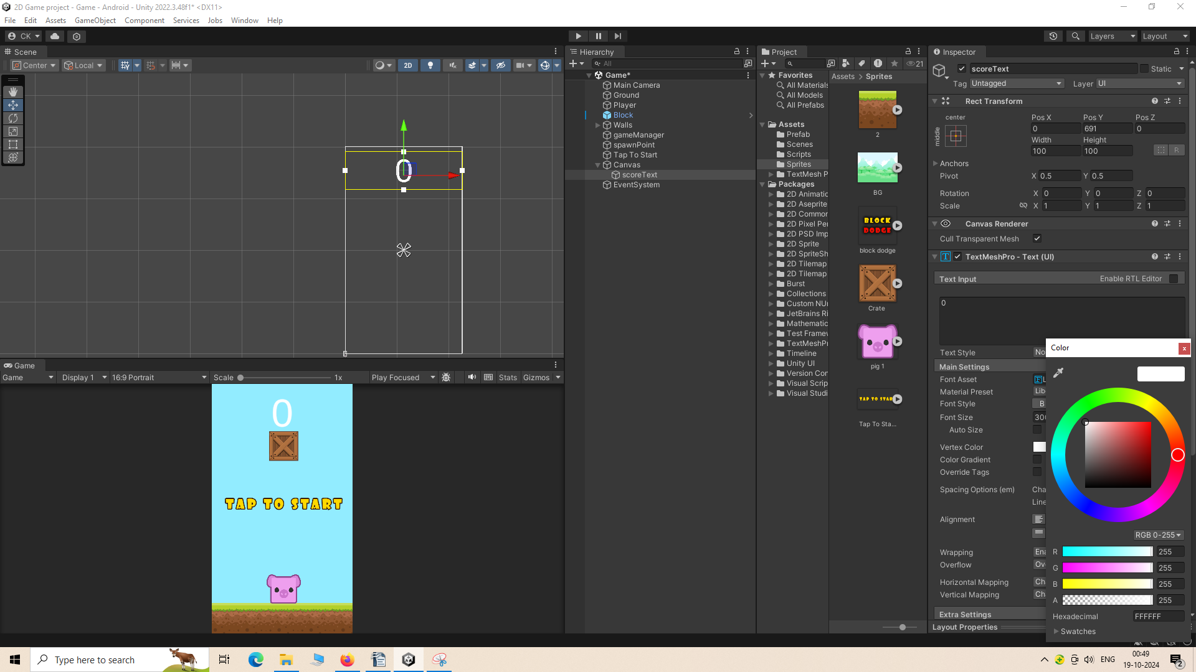
Note:-
The alpha value we see in color picker i think decide the how dark and light it is in its color

So now all we need to do is write code so that our gets increment and automatically it gets updated
on the scoreText on the screen (after the player dodge the block)
So for that we go to GameManager code.
And make a reference variable of type GameObject which will store the reference of tap to start IOA.
This tap text will be disabled when the gameStarted.
Now to reference to our scoreTextMeshPro scoreText we need a class TextMeshProGUI and we will import TMPro to use this class
we write another variable named score of integer type
Now we need to find a mechanism so that the score text get incremented automatically.
To that what we need to do is increment the score when a block is spawned.
(From my research i have come acroos to the conclusion you can refer a normal IOA in script of prefab)
After updating in the variable we need to update in UI also.
To disable our tap to start we use the method setactive method in the object of its IOA
and pass the argument false
To set the UI according to the score
we initialise the text property of the scoretext with String of our score by ToString method
and make sure to add the respective IOA froim heorarchy to their respected field in the script block
Now our code will look like below
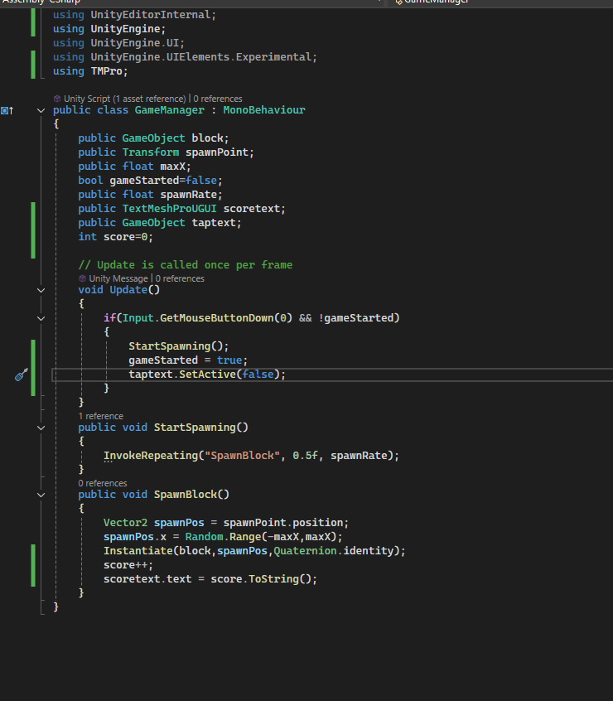
Note:-
the center of the IOA is taken for the position of x,y,z.
Now whenever you tap on the screen for the first time the tap to text will be removed from the screen and the random block will come from above the screen and from random places above the screen

